Software Design
for

Campus Management Application
at
World Skill Center (WSC)

Design Feature - Students Management Module



Sustainable Outreach And Universal Leadership (SOUL) Limited
Version no 0.2
VERSION HISTORY
Date | Version No. | Created By | Updated Section | Updated By
20-02-2022 | Version 0.1 | Priytesh Shah

Contents

1. Introduction 5
2. Literature review 6
3. Platform Overview 6
3.1 Platform requirements 6
3.1.1 Software Stack 6
3.2.2 Hosting requirement 7
4. Architecture 7
5. Organization Structure: 8
6. Design Overview: 8
6.1 Student Group 8
6.1.1 Overview 8
6.1.2 Description of Problem 8
6.1.3 Dependency 9
6.1.4 A Table of Contents 9
6.1.5 Flow Chart 9
6.1.6 Use Case 10
6.1.7 Form Elaboration 10
6.1.8 Screen Authorization 11
6.1.9 Component And Module 12
6.1.10 Business Logic 12
6.1.11 Path of the screen 12
6.2 Student Group 12
6.2.1 Overview 12
6.2.2 Description of Problem 12
6.2.3 Dependency 13
6.2.4 A Table of Contents 13
6.2.5 Use Case 13
6.2.6 Form Elaboration 13
6.2.7 Screen Authorization 14
6.2.8 Component And Module 14
6.2.9 Business Logic 14
6.2.10 Path of the screen 15
6.3 Course Schedule 15
6.3.1 Overview 15
6.3.2 Description of Problem 15
6.3.3 Dependency 15
6.3.4 A Table of Contents 15
6.3.5 Use Case 16
6.3.6 Form Elaboration 16
6.3.7 Screen Authorization 17
6.3.8 Component And Module 17
6.3.9 Business Logic 17
6.3.10 Path of the screen 17
6.4 Course Schedule 17
6.4.1 Overview 17
6.4.2 Description of Problem 17
6.4.3 Dependency 17
6.4.4 A Table of Contents 18
6.4.5 Use Case 18
6.4.6 Form Elaboration 18
6.4.7 Screen Authorization 18
6.4.8 Component And Module 19
6.4.9 Business Logic 19
6.4.10 Path of the screen 19
6.5 Course Schedule 19
6.5.1 Overview 19
6.5.2 Description of Problem 19
6.5.3 Dependency 19
6.5.4 A Table of Contents 19
6.5.5 Use Case 20
6.5.6 Form Elaboration 20
6.5.7 Screen Authorization 21
6.5.8 Component And Module 21
6.5.9 Business Logic 21
6.5.10 Path of the screen 21
6.6 Student Leave Application 21
6.6.1 Overview 21
6.6.2 Description of Problem 21
6.6.3 Dependency 21
6.6.4 A Table of Contents 22
6.6.5 Use Case 22
6.6.6 Form Elaboration 22
6.6.7 Screen Authorization 23
6.6.8 Component And Module 23
6.6.9 Business Logic 23
6.6.10 Path of the screen 23
6.7 Mentor Allocation 24
6.7.1 Overview 24
6.7.2 Description of Problem 24
6.7.3 Dependency 24
6.7.4 A Table of Contents 24
6.7.5 Use Case 24
6.7.6 Form Elaboration 25
6.7.7 Screen Authorization 25
6.7.8 Component And Module 25
6.7.9 Business Logic 25
6.7.10 Path of the screen 25
6.8 Mentor Mentee Communication 26
6.8.1 Overview 26
6.8.2 Description of Problem 26
6.8.3 Dependency 26
6.8.4 A Table of Contents 26
6.8.5 Use Case 26
6.8.6 Form Elaboration 26
6.8.7 Screen Authorization 27
6.8.8 Component And Module 27
6.8.9 Business Logic 27
6.8.10 Path of the screen 27

- Introduction

Campus management project for WSC aims at providing an efficient, secure, and user-friendly platform to manage and automate the various processes. It is an integrated system that provides all the necessary tools to manage the various aspects of running a University. This web-based solution enables administrators and faculty to easily track and manage activities related to student registration and enrollment, faculty and staff management, financial management, facility management, and more. Additionally, it also provides features such as reporting and analytics, notification to students and parents using emails.
Scope of project:
- Students Management Modules
- Academic System
- Procurement & Inventory Management
- Human Resources Management System
- Finance and Accounting System
- Training and Placement
- Infrastructure

- Literature review
The following section first explains the evolution of ERP system and some of its characteristics. It also explores the various modules available in an ERP software. Knowledge-intensive nature of ERP systems and ERP system adoption is also analyzed. Finally it looks into critical success factors for ERP system implementation as well as benefits of ERP implementation.

- Platform Overview

3.1 Platform requirements

3.1.1 Software Stack
Our application use Frappe framework as the major software stack which is an open-source full stack web framework written in Python and JavaScript that is used to develop and maintain web applications. It is designed to be simple, easy to use, and fast. It is built on top of the popular Django web framework. Frappe provides a powerful set of tools for building web applications with a focus on scalability and extensibility. It provides a powerful ORM, a powerful templating system, and a comprehensive set of APIs for building web applications. Frappe is also designed for ease of use, with a focus on reducing development time and building an intuitive admin interface. It also features a seamless integration with other open-source projects such as Redis, MongoDB, and MySQL, as well as a host of APIs and other tools.

3.2.2 Hosting requirement
Our application requires a Linux-based hosting environment. It requires at least 1GB of RAM, 2GB of disk space, and preferably an Ubuntu 16.04 or higher operating system. It also requires a web server such as Apache or Nginx, MariaDB 10.1 or higher, and Python 2.7.x or higher. Additionally, it requires an SMTP server to send emails and an SSL certificate to enable HTTPS.

- Architecture
Our application is based on a web-based, modular, service-oriented architecture (SOA), which allows for the development of custom applications and services that can be integrated with the core Our application platform. It is built on a combination of JavaScript, Python, and MySQL. The architecture of Our application consists of multiple layers, each with its own set of functions and services. At the highest level are the user interface, user experience, and application logic components. These components provide the user with an interface to the Our application system and the ability to interact with the underlying data and services. Below the user interface layer is the data layer, which is responsible for managing the storage and retrieval of data and services. This layer is powered by a combination of MySQL and PostgreSQL databases. The data layer is also responsible for providing secure access to the data and services. The application layer is responsible for providing access to the data and services, as well as providing the business logic that drives the system. The application layer is powered by a combination of Python and JavaScript, and is responsible for providing the core capabilities of the system, such as authentication, authorization, reporting, and analytics. Finally, the service layer is the layer that connects the application layer to the user interface layer. It provides the ability to integrate the Our application system with external systems and services, such as third-party APIs and web services. The service layer is powered by a combination of web services and web sockets. Following is a diagram showing a representation of the architecture of our application:

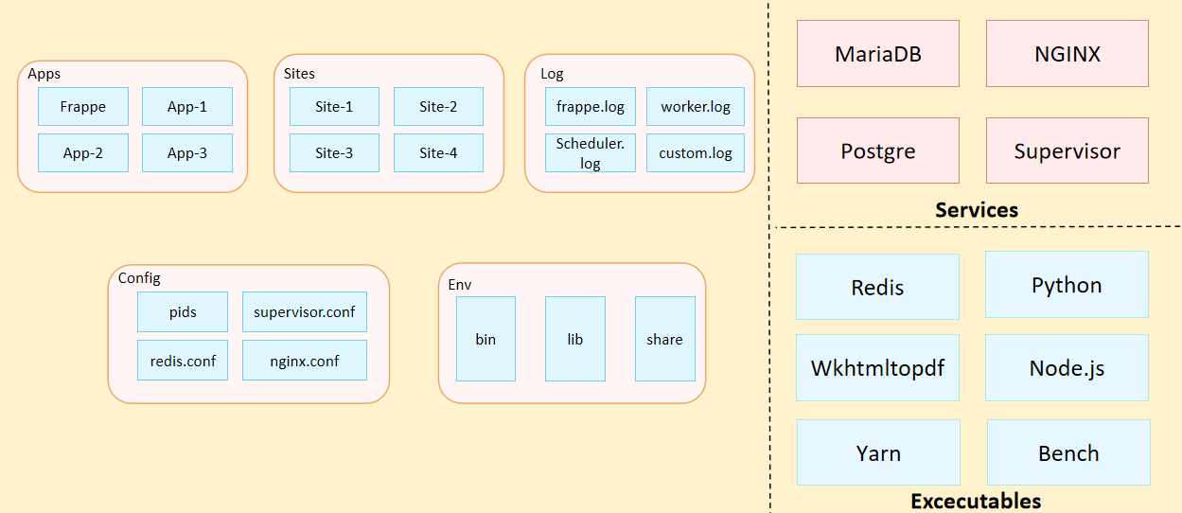
Fig: Architecture of Our Application

- Organization Structure:
Input required form WSC

- Design Overview:

6.1 Student Group
    - Overview
A student group is a collection of students from the same batch or taking the same course.
    - Description of Problem
Create a form containing all Information about student based on Batch, Courses, etc. Containing list of students, Instructor and room to group them together in one form.

    - Dependency
Before creating a Student Group, it is advisable you create the following documents:
- Student
- Program Enrollment
- Instructor
- Room
- Program
- Semester
- Courses

    - A Table of Contents
- Main Table:- TabStudent Group
- Child Table:-
- TabMultiples Programs
- TabStudent Group Student
- TabStudent Group Instructor
- TabInvigilator List

    - Flow Chart
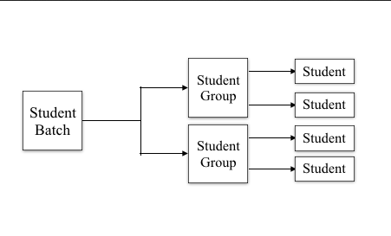
    - Use Case

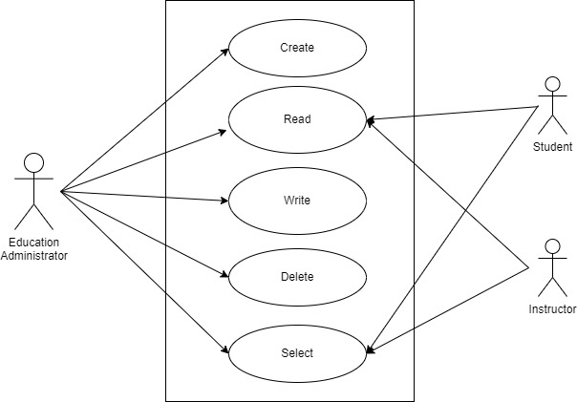

    - Form Elaboration
Sl No. | Field name | Field type | Mandatory
1 | Group Creation Date | Date | 0
2 | Academic Year | Link | 1
3 | Group Based on | Select | 1
4 | Exam Declaration | Link | 0
5 | Exam Schedule Date | Date | 0
6 | From Time | Time | 0
7 | To Time | TIme | 0
8 | Student Group Name | Data | 1
9 | Class Room | Link | 0
10 | Total Capacity | Int | 0
11 | Max Strength | Int | 0
12 |  | Column Break | 0
13 | Generate Roll No | Button | 0
14 | Roll Number Series | Select | 0
15 | Academic Term | Link | 0
16 | Program Grade | Link | 0
17 | Programs | Link | 0
18 | Program | Link | 0
19 | Batch | Link | 0
20 | Student Category | Link | 0
21 | Course | Link | 0
22 | Course Code | Data | 0
23 | Course Name | Data | 0
24 | Disabled | Check | 0
25 |  | Section Break | 0
26 | Multiples Programs | Table | 0
27 | Students | Section Break | 0
28 | Get Students | Button | 0
29 | Students | Table | 0
30 | Instructors | Section Break | 0
31 | Instructors | Table | 0
32 | Invigilator List | Table | 0
33 |  | Section Break | 0
34 | Mentor Allocation | Link | 0
35 |  | Column Break | 0
36 | Mentor | Link | 0
37 |  | Section Break | 0
38 | Roll No | Data | 0

    - Screen Authorization
Sl No. | Role | Select | Read | Write | Create | Delete
1 | Education Administrator | 1 | 1 | 1 | 1 | 1
2 | Instructor | 1 | 1 | 1 | 1 | 1
3 | Student | 1 | 1 | 1 | 1 | 1

    - Component And Module
Module Related:- Education

    - Business Logic
- Go to Student Group List and click on New.
- Group Based On: Select the basis on which you would like to create the student group. The three options available are:
- Batch: List of all the students from within a specific batch will be fetched in this case.
- Course: List of all the students who have enrolled for a specific course will be fetched in this case.
- Activity: You can select this option when you want to create a group of students for certain activities happening in the school.
- Student Group Name: Enter the name of the student group.
- Save.

    - Path of the screen
Home > Academics > Groups & Schedule > Student Group

6.2 Student Group

6.2.1 Overview
A Course Scheduling Tool will allow you to create Course Schedules in bulk for a particular Student Group and an Instructor.

6.2.2 Description of Problem
Create a tool which will allow you to create Course Schedules in bulk.

6.2.3 Dependency
Before creating a Student Group, it is advisable you create the following documents:
- Instructor
- Student Group
- Program
- Semester
- Courses

6.2.4 A Table of Contents
- Main Table:- TabCourse Scheduling Tool

6.2.5 Use Case
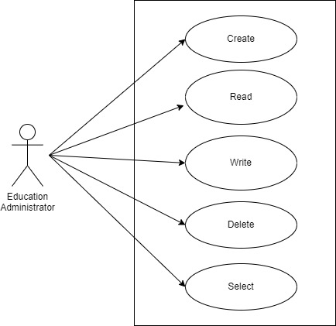

6.2.6 Form Elaboration
SL No | Field Name | Field Type | Mandatory
1 | Student Group | Link | 1
2 | Course | Link | 1
3 | Program | Link | 0
4 |  | Column Break | 0
5 | Academic Year | Link | 0
6 | Academic Term | Link | 0
7 |  | Section Break | 0
8 | Instructor | Link | 1
9 | Instructor Name | Read Only | 0
10 |  | Column Break | 0
11 | Room | Link | 1
12 |  | Section Break | 0
13 | Days | HTML | 0
14 |  | Section Break | 0
15 | From Time | Time | 1
16 | Course Start Date | Date | 1
17 |  | Column Break | 0
18 | To TIme | Time | 1
19 | Course End Date | Date | 1
20 | Reschedule | Check | 0

6.2.7 Screen Authorization
Sl No. | Role | Select | Read | Write | Create | Delete
1 | Education Administrator | 1 | 1 | 1 | 1 | 0

6.2.8 Component And Module
Module Related:- Education

6.2.9 Business Logic
- Select and add the Student Group. Once you do this, the Academic Term, Academic Year the Program will be auto-populated.
- Select and add the Course.
- Select and add the Instructor whose lectures are being scheduled using the tool.
- Select and add the Room wherein the lectures will take place.
- Change the From Time and To Time to your desirable schedule.
- Select the Course Start Date and the Course End Date for the Course Schedule.
- Select the Day of the week on which the Course Lecture has to be scheduled.
- Click on Schedule Course button, based on the dates selected and days for the course selected, the Tool will schedule the required course lectures.

6.2.10 Path of the screen
Home > Academics > Tools > Course Scheduling Tool

6.3 Course Schedule

6.3.1 Overview
Course Schedule can be used for scheduling a particular course by an Instructor.

6.3.2 Description of Problem
Create a form to Schedule classes taken by Instructor.

6.3.3 Dependency
Before creating a Student Group, it is advisable you create the following documents:
- Instructor
- Student Group
- Program
- Semester
- Courses

6.3.4 A Table of Contents
- Main Table:- TabCourse Schedule
- Child Tables:-
- TabAdditional Instructor
- TabStudent Paper Code

6.3.5 Use Case
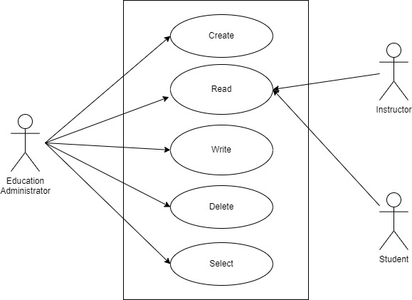

6.3.6 Form Elaboration
SL No. | Field Name | Field Type | Mandatory
1 | Student Group | Link | 1
2 | Is exam schedule | Check | 0
3 | Instructor | Link | 1
4 | Instructor Name | Read Only | 0
5 | Additional Instructor | Table
6 |  | Column Break | 0
7 | Naming Series | Select | 0
8 | Program | Link | 0
9 | Course | Link | 1
10 | Course Name | Data | 0
11 | Course code | Data | 0
12 | Color | Color | 0
13 |  | Section Break | 0
14 | Schedule Date | Date | 0
15 | Room | Link | 1
16 | Room Name | Data | 0
17 |  | Column Break | 0
18 | From Time | Time | 1
19 | To Time | Time | 1
20 | Title | Data | 0
21 |  | Section Break | 0
22 | Exam Declaration | Link | 0
23 | Student Paper Code | Table | 0
24 | Mentor Allocation | Link | 0

6.3.7 Screen Authorization
Sl No. | Role | Select | Read | Write | Create | Delete
1 | Education Administrator | 1 | 1 | 1 | 1 | 1
2 | Instructor | 1 | 1 | 1 | 1 | 0

6.3.8 Component And Module
Module Related:- Education

6.3.9 Business Logic
- Create a new Course Schedule from the Schedule Calendar.
- Select the Student Group for which you want to create the Course Schedule.
- Select the Instructor who will be tutoring the students for the course.
- Select the Course for which the schedule is being prepared.
- Add the From Time and To Time for the Course Schedule.
- Select and add the Room wherein the Lecture would be conducted.

6.3.10 Path of the screen
Home > Academics > Groups & Schedule > Course Schedule

6.4 Course Schedule

6.4.1 Overview
The Student Attendance tool allows you to bulk update the attendance for students based on Student Group and Course Schedule.

6.4.2 Description of Problem
Create a form to mark student attendance in bulk.

6.4.3 Dependency
Before creating a Student Group, it is advisable you create the following documents:
- Instructor
- Student Group

6.4.4 A Table of Contents
- Main Table:- TabStudent Attendance Tool

6.4.5 Use Case

6.4.6 Form Elaboration
SL No. | Field Name | Field Type | Mandatory
1 | Based On | Select | 0
2 | Group Based On | Select | 0
3 |  | Column Break | 0
4 | Student Group | Link | 1
5 | Academic Year | Link | 0
6 | Academic Term | Link | 0
7 | Course Schedule | Link | 1
8 | Date | Date | 1
9 | Attendance | Section Break | 0
10 | Students | HTML | 0

6.4.7 Screen Authorization
Sl No. | Role | Select | Read | Write | Create | Delete
1 | Education Administrator | 1 | 1 | 1 | 1 | 0
2 | Instructor | 1 | 1 | 1 | 1 | 0

6.4.8 Component And Module
Module Related:- Education

6.4.9 Business Logic
To mark the Attendance based on Student Group select the group based on:
- Batch
- Course
- Activity
Student details will be auto-fetched and you can mark the attendance of the given date.
6.4.10 Path of the screen
Home > Academics > Attendance & Leave Application > Student Attendance Tool

6.5 Course Schedule

6.5.1 Overview
Student Attendance allows you to track and manage the attendance of a student for a day. The Attendance module is designed to help teachers easily mark student attendance during class.

6.5.2 Description of Problem
Create a form to mark student attendance individually.

6.5.3 Dependency
Before creating a Student Group, it is advisable you create the following documents:

- Student Group
- Course Schedule

6.5.4 A Table of Contents
- Main Table:- TabStudent Attendance

6.5.5 Use Case
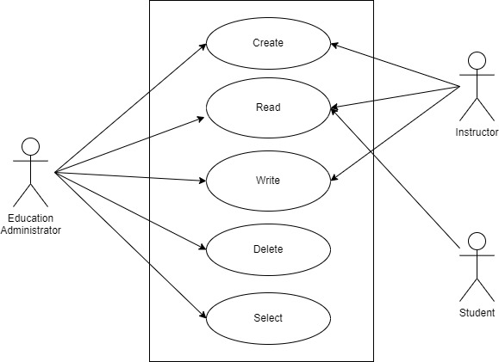

6.5.6 Form Elaboration
Sl No. | Field name | Field Type | Mandatory
1 | Series | Select | 0
2 | Attendance for | Select | 1
3 | Student | Link | 1
4 | Student Name | Read Only | 0
5 | Student Mobile Number | Read Only | 0
6 | Roll No | Data | 0
7 | Registration Number | Data | 0
8 | Course | Link | 0
9 | Topic | Link | 0
10 | Instructor | Link | 0
11 | Course Schedule | Link | 0
12 | Student Group | Link | 0
13 |  | Column Break | 0
14 | Date | Date | 1
15 | Status | Select | 1
16 | Schedule Type | Link | 0
17 | Exam Declaration | Link | 0
18 | Paper Code | Data | 0
19 | Leave Application | Link | 0
20 | Hostel details | Link | 0
21 | Building | Link | 0
22 | Hostel Room | Link | 0
23 | Hostel Leave Application | Link | 0

6.5.7 Screen Authorization
Sl No. | Role | Select | Read | Write | Create | Delete
1 | Education Administrator | 1 | 1 | 1 | 1 | 1
2 | Instructor | 1 | 1 | 1 | 1 | 0
3 | Student | 0 | 1 | 0 | 0 | 0

6.5.8 Component And Module
Module Related:- Education

6.5.9 Business Logic
Select the Student, Course Schedule, and Student Group for which attendance is to be marked for the given date. Set the Status to Present/Absent and save.

6.5.10 Path of the screen
Home > Academics > Attendance & Leave Application > Student Attendance

6.6 Student Leave Application

6.6.1 Overview
Student Leave Application is a formal document to keep a track of leaves for a student.

6.6.2 Description of Problem
Create a from which student can apply for leave.

6.6.3 Dependency
Before creating a Student Group, it is advisable you create the following documents:
- Student
- Student Group
- Holiday List

6.6.4 A Table of Contents
- Main Table:- TabStudent Leave Application

6.6.5 Use Case
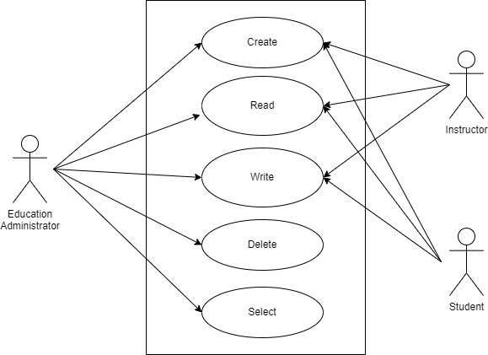

6.6.6 Form Elaboration
SL No. | Field name | Field Type | Mandatory
1 | Student | Link | 1
2 | Student Name | Read Only | 0
3 | Roll No | Data | 0
4 | Registration Number | Data | 0
5 |  | Column Break | 0
6 | From Date | Date | 1
7 | To Date | Date | 1
8 | Total Leave Days | Float | 0
9 |  | Section Break | 0
10 | Attendance Based On | Select | 0
11 | Student Group | Link | 0
12 | Course Schedule | Link | 0
13 | Mark as Present | Check | 0
14 |  | Column Break | 0
15 | Reason | Text | 0

6.6.7 Screen Authorization
Sl No. | Role | Select | Read | Write | Create | Delete
1 | Education Administrator | 1 | 1 | 1 | 1 | 1
2 | Instructor | 1 | 1 | 1 | 1 | 0
3 | Student | 1 | 1 | 1 | 1 | 1

6.6.8 Component And Module
Module Related:- Education

6.6.9 Business Logic
- Go to the Student Leave Application list, and click on New.
- Select the Student.
- Set the 'From Date' and 'To Date' fields for specifying the period.
- Marking Attendance for the Leave Application is governed by the 'Attendance Based On' field. Student Attendance can be marked in two ways:
- Course Schedule: If attendance is taken for every lecture (in colleges/universities), then the leave application can be created for that particular course schedule slot.
- Student Group: If attendance is taken for the entire day then student group (class/division) is used to mark attendance so that leave is calculated for the entire day
- Based on the Attendance field, select the Student Group or Course Schedule. Optionally enter the reason.
- In case the student is not attending the institute to participate or represent the institute in any event, he/she can be marked as "Present" from the Leave Application itself by checking Mark as Present.
- Save. The 'Total Leave Days' will be calculated and set in the document after excluding the holidays which are part of your default Holiday List.

6.6.10 Path of the screen
Home > Academics > Attendance & Leave Application > Student Leave Application

6.7 Mentor Allocation

6.7.1 Overview
Mentor Allocation is a form where you allocate a group of student under an Instructor as a mentor.

6.7.2 Description of Problem
Create a form which can be used to assign an Instructor as a Mentor for a group of students.

6.7.3 Dependency
Before creating a Student Group, it is advisable you create the following documents:
- Employee
- Student
- Program
- Semester

6.7.4 A Table of Contents
- Main Table:- TabStudent Leave Application
- Child Table:- TabMentee List

6.7.5 Use Case

6.7.6 Form Elaboration
Sl No. | Field Name | Field Type | Mandatory
1 | Mentor | Link | 1
2 | Mentor Name | Data | 0
3 | Allocation from | Link | 0
4 | Allocation To | Link | 0
5 |  | Column Break | 0
6 | Academic Year | Link | 1
7 | Programs | Link | 1
8 | Semester | Link | 0
9 |  | Section Break | 0
10 | Mentee List | Table | 0

6.7.7 Screen Authorization
Sl No. | Role | Select | Read | Write | Create | Delete
1 | Education Administrator | 1 | 1 | 1 | 1 | 1
2 | Instructor | 0 | 1 | 0 | 0 | 0
3 | Student | 0 | 1 | 0 | 0 | 0

6.7.8 Component And Module
Module Related:- Education

6.7.9 Business Logic
- Go to the Mentor Allocation list, and click on New.
- Select the Mentor.
- Set the 'Allocation from' and 'Allocation To' fields for specifying the period.
- Enter Academic Year, Programs, Semester.
- After entering all this inputs we can assign student for a mentor to assign students as Mentee.
- Save.

6.7.10 Path of the screen
Home > Academics > Mentor-Mentee >Mentor Allocation

6.8 Mentor Mentee Communication

6.8.1 Overview
Mentor Mentee Communication is a form both the mentor and mentee can communicate over any kind of topic or issue.

6.8.2 Description of Problem
Create a form which can be used as communication channel between mentor and mentee.

6.8.3 Dependency
Before creating a Student Group, it is advisable you create the following documents:
- Student

6.8.4 A Table of Contents
- Main Table:- TabStudent Leave Application
- Child Table:- TabMentee List

6.8.5 Use Case

6.8.6 Form Elaboration
Sl No. | Field Name | Field Type | Mandatory
1 | Date | Date | 0
2 | Student | Link | 1
3 | Student Name | Data | 0
4 | Programs | Link | 1
5 |  | Column Break | 0
6 | Mentor Allocation | Link | 0
7 | Mentor Name | Data | 0
8 |  | Section Break | 0
9 | Description | Text Editor | 0
10 | References | Section Break | 0
11 | Student Disciplinary Complain | Link | 0

6.8.7 Screen Authorization
Sl No. | Role | Select | Read | Write | Create | Delete
1 | Education Administrator | 1 | 1 | 1 | 1 | 1
2 | Instructor | 1 | 1 | 1 | 1 | 0
3 | Student | 1 | 1 | 1 | 1 | 1

6.8.8 Component And Module
Module Related:- Education

6.8.9 Business Logic
- Go to the Mentor Mentee Communication list, and click on New.
- Select the Student.
- Enter Description.
- Save.

6.8.10 Path of the screen
Home > Academics > Mentor-Mentee > Communication

